Mission Trip Sponsorship Commitment Form
  - 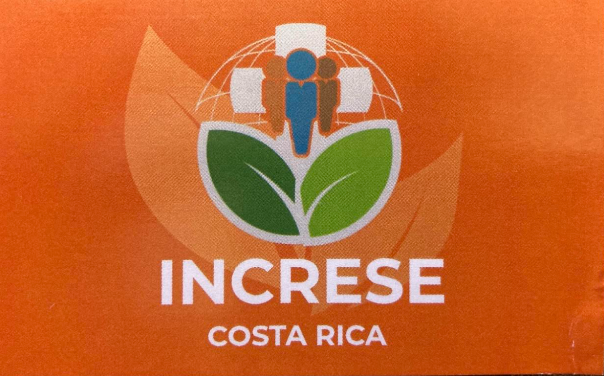

I. Our Mission & Purpose
• The Mission: Southern Hills Evangelical Free Church (SHEF) is partnering with Increse to share the Gospel of Jesus Christ in Costa Rica from April 3rd to April 13th, 2026.
• The Impact: Your generous partnership will directly fund travel expenses, ministry materials, outreach supplies, and local support needed to carry out this mission.
• Funding Goal: We aim to raise a total of $20,000 to cover all participants and operational costs for this mission trip.

II. Sponsor Contact Information
Please provide the details of the sponsoring organization and the primary contact person.
Sponsoring Organization Name:
Contact Person Name & Title:
Address:
City, State, Zip Code:
Phone Number:
Email Address:
Website (if applicable):
Tax ID / EIN:

III. Partnership Levels & Recognition
Your contribution helps us meet essential costs for the team and local outreach efforts.
Level | Contribution Amount | Recognition & Partnership Benefits
Outreach Partner | $1,000+ | Prominent logo placement on pre- and post-trip communication; Photo update from the team in Costa Rica featuring your organization's name/logo; Recognition at a post-trip appreciation event
Travel Partner | $500 - $999 | Logo inclusion on a Thank-You insert distributed with SHEF materials; Recognition in SHEF’s general communications regarding the mission trip
Resource Partner | $250 - $499 | Listing of organization's name in a dedicated 'Mission Sponsors' section on the SHEF website/bulletin.
Custom Contribution | $ any amount | We are grateful for all support! Please specify if you prefer anonymous donation.

Payment Instructions:
Please make checks payable to Southern Hills Evangelical Free Church (SHEF) or visit our online giving portal.
Return Deadline: March 1st, 2026
Sponsor Signature: ____________________________ Date: ____________________________

